**CONCEPTUAL ART APPROACHES IN DESIGN EDUCATION**

**1.0 Introduction**

Students starting bachelor programs in product design have a preconception of design. The study program for the “art and design” specialization in the Norwegian high school emphasizes on traditional design processes such as formal studies in form vernacular as approach to creative and artistic work. However for students to see the potential of how products can elicit experiences on various levels and in broad contexts, they need to break with their product oriented emphasis as starting point for their design process.

This article introduces the creative technique of “deconstruction”, identified in the contemporary conceptual art practise which was studied through a case study involving student projects and interviews.

The creative technique made the premises for the working method in two design projects for different first year bachelor students in a product design education. The task was to design a new product out of the existing IKEA product; stool “ODDVAR” in 2011 and box ”PRÄNT ” in 2012. The aim of the project was to introduce the idea of conveying experiences or associations connected to one existing product into a new product concept. This was done in order to facilitate the students’ comprehension of products as a possible performer on different levels in society enabling diverse experiences in different contexts.

The projects ended up in diverse product concepts untied from the product that made the basis for the study in relation to function and expression. One key finding is that the technique of deconstruction facilitated a variation in approaches by the students that consequently led to a variety in product concepts.

In this article we will firstly give an overview over conceptual art processes, a description of a case study in design education. The possible enabling factors will be discussed in relation to three hypothesis: *Hypothesis 1: The degree of experienced quality does not depend on material volume. Hypothesis 2:* The deconstruction of an already existing product stimulates a thorough and diversified analysis. *Hypothesis3: A confined space defined by hands on skills already gained and practiced by the students will force students to think more about the meaning or goal with the product*

***1.1 Contemporary conceptual art***

In the beginning of the nineties there was an increasing emphasis on contextualization in fine art education and practice. This involved that artists had to find contexts or argumentation for their work with for example basis in conceptual, social or political domains. The need to find a link to the world outside the established art scene can be found in a more resent artwork by Matias Faldbakken, in his work “Cultural Department 2006” he links a possible first experience of a expressionistic wall painting or graffiti to an image of the appearance of the Palestinian Cultural Departments after a period of occupation by Israeli soldiers in 2002. Consequently what the work communicates can be perceived on several layers, firstly the graffiti can give the impression of a direct expression on a wall seemingly fun to make.  A work of this kind applied directly on to the walls, some art spectators might find surprising to find in the National Museum of Contemporary Art in Oslo .The painting being applied directly on to the walls, involves that the work will only exist for the limited time period of the exhibition, and after that be removed. A small text on the wall informs the viewer about the background of the work namely a media image from the ongoing conflict between the Palestinian and Israeli.

Another example of that can give insight to the technique of contextualizing from fine art is the work by Ole Jørgen Ness.  He established different dimensions for his work through creating nine different identities as an artist. This enabled him to work within a wide range of expressions and art directions, from figurative painting to strictly conceptual art approaches. In 1994 this project accumulated in a staged video piece “Opus Osiris” in the form of a conference with the different identities as participants.

In the artwork “Blue Boat Black” (1997) by the British conceptual artist Simon Stirling we find  the method/thinking behind the work to be especially relevant for this study since the main understanding namely describes the emancipation from esthetics and materials. Aspects we find serving as constraints for creative thinking. In this work Starling make use of transformation of a disused museum display case from The Nathional Museum of Scotland, Edinburgh, he transported it to Marseille and resurrected it temporarily in to the form of a small fishing boat, went fishing and then burned the boat in order to be able to cook the fish. Starling says about this piece” coming full circle the remains of the boat returned to the museological realm in the form of the charred remains, testament to the cycle of construction and deconstruction, use and re- use. Starling talks about his work as ”a fyschical manifestation of a thought proses”. This way of working with art has strong references in the conceptual art movement. Typical for the conceptual art is the creation of rules that serves as parameters for the work. The technique or medium that is used to produce the work is of less importance. Hence the content, the thinking or the idea of the creation make the essence of the work.

Sol Le Witt has defined conceptual art as “conceptual art is art in which the concepts or ideas involved in the work take precedence over traditional aesthetic and material concerns. (Sol Le Witt, 1928-2007).

**2.0 METHOD**

The creative technique is explored through a cases study that involved student projects and interviews. The project was given with a method resembling the approach of the artists mentioned in the introduction. We have chosen to call this method “deconstruction of a found object”. The process involved the demand of transforming one existing object form IKEA namely the stool “ODDVAR” in 2011 and ” the box PRÄNT ”  in 2012 into a new product.

**3.0 CASE STUDY, STUDENT PROJECT AT HIOA**

***3.1 Description of the student task***

The students were given the task to transform the stool/box into new, forms, ideas, expressions and/or functions. The constraints the students were given was that they could only use the material from the stool/box to execute the work.

***3.2 Deconstruction:***

Exercise 1 for the students was to work in groups of 5, with 5 boxes and cello tape as corrosion for a limited period of time (1 hour). They could choose between the keywords: construction for 2, high construction and gateway.

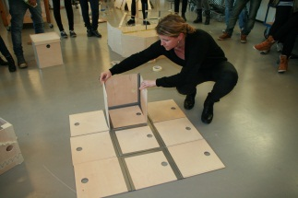 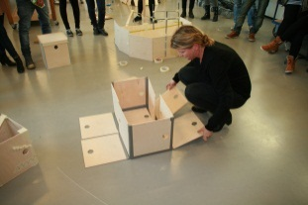 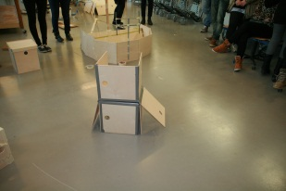

Figure 1. Students performing analysis on the box ” PRÄNT” from IKEA

One other starting exercise for the students was to draw the product in Rhino 3D drawing program. This involved having to measure each component/element/part, draw them and fix them together. The next step was to start making changes.

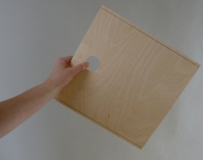  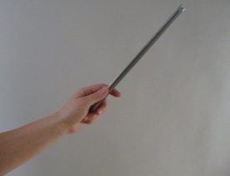 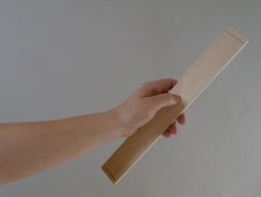

Figure 2. Analysis on the box ” PRÄNT ”

***3.3 Reconstruction***

To kick of the reconstruction proses the students were given the choice to use the following instructions to develop many diverging ideas; Make at least four drafts/sketches for the transformation of the stool/box: (1) based on the transformation of *form or expression*. (2) based on the transformation of *function*. (3) based on the transformation of the *material*. (4) based on the method of “forced relationship”(for example combine the word box/stool with a random word) to promote unorthodox ideas. These sketches was then presented and discussed in group tutorials, and formed for some of the students the background for their working proses.



Figure 3. Examples of components from the box ” PRÄNT ” applied in products

**4.0 FINDINGS & FINAL REMARKS**

In general the student demonstrated a variety in the working approaches and consequently in the project outcomes. The projects spanned from big nonfunctional objects to machinelike products.

The students interviewed found the process frustrating, the assignment was experienced as too open and that it lacked demands for a final product. This perceived frustration and lack of a common goal description however seems to have enabled the students to define their own approach and to adopt or employ necessary skills in order to start and finalize their projects. As one student said, “the biggest challenge was to find ideas and to start defining my own structure and starting point for the investigation”. Such a challenge enabled the students to define their own goal and approach towards the project. Moreover this lead some students towards products that were rooted in their personal interests, inspiration and life experience. Products seemingly without any function emerged such as wooden carpet made with the goal to give an impression of plywood having the characteristics as textile. One of the students that was interviewed said that he had to look at the box which was the starting point for one assignment from different perspectives, for example as a designed object that he had opinion about and maybe wanted to do better, as a stack of plywood, as a piece of cheap furniture made to fit into most homes. He even calculated how much money IKEA in this case earned on each item.

Further analysis and research work on the outcome of processes as described would be interesting to perform in light of perceived levels of experience that the products elicit. This paper does not investigate this.

***Some key findings that might be of general interest:***

1. *The deconstruction of an already existing product stimulates a thorough and diversified analysis.*
2. *A confined space defined by the transformation of a product seems to enable students to consider what the meaning or goal with the product is*
3. *There was a tendency to convey principles of construction from the existing product to the new*
4. *There was a tendency to regarded the very constrained working space as described a very open assignment*
5. *The variability in themes might be due to a more emancipated attitude towards the design process because of the rigid and confined working space*

All four points might serve as a knowledge transfer into other contexts.

Starting point for the investigation, transformation of the given object and the outcomes does not easily categorize within a one or a few themes. The process seems therefore to motivate the student to define its own field of interest and approach- a processes similar to the one of contemporary artist. Such a motivation might emancipate and lead the student in other directions than the traditional design sphere.

**REFERENCES:**

Janet, M. (2011). Impositions of order: A comparison between design and fine art practices. *Design Studies, 32*(6), 557-572. doi: 10.1016/j.destud.2011.07.003

Gro Ellen Mathisen, Kolbjorn S. Bronnick (2009) Creative self - efficacy: An intervention study. University of Stavanger, Norway.

Heape, C. (2007). The Design Space - the design process as the construction, exploration and expansion of a conceptual space. Mads Clausen Institute for Product Innovation. Sønderborg, University of Southern Denmark. **PhD:** 382.